**ACTION ITEMS STATUS REPORT**

|  |  |
| --- | --- |
| **Report Date** | **Project Name** |
| **July 2022** | **Automated In-Plant Line Inspection Reporting System** |

|  |  |  |  |  |
| --- | --- | --- | --- | --- |
| **Task, Actions Items, Milestones, Deliverables Overview** | | | | |
| **Task/Action Items / Milestones** | **Actions/ Solutions Performed** | **Status** | **Date Completed** | **% Complete** |
| * Meeting with Process owner | * Discussion for the pages | Completed | 07/01/2022 | 100% |
| * Species must have select / deselect all function | * Added an option for the select and deselect selected data | Completed | 07/15-31/2022 | 100% |
| * Duplicated input multiple species | * Created a validation for the existing Diseases | Completed | 07/15-31/2022 | 100% |
| * Fields for validation (Username, LTO Number ) | * Created a validation for the existing username and LTO number | Completed | 07/15-31/2022 | 100% |
| * Add Diseases or Conditions | * Changing the header title for the diseases page | Completed | 07/15-31/2022 | 100% |
| * Diseases and Conditions | * Changing the header title for the sidebar | Completed | 07/15-31/2022 | 100% |
| * Question mark | * Remove question mark disease status and change the option yes or no to Notifiable / Not Notifiable. | Completed | 07/15-31/2022 | 100% |
|  |  |  |  |  |
|  |  |  |  |  |
|  |  |  |  |  |
|  |  |  |  |  |
|  |  |  |  |  |
|  |  |  |  |  |
|  |  |  |  |  |
|  |  |  |  |  |
|  |  |  |  |  |
|  |  |  |  |  |
|  |  |  |  |  |
|  |  |  |  |  |
| * Other column not filtering from code -> disease | * Added new column | Completed | 07/15-31/2022 | 100% |

|  |  |
| --- | --- |
| **Version and Patch History** | |
| **Versions** | **Patch Updates Release** |
| January Changes and Updates | January 2022 |
|  |  |

|  |
| --- |
| Additional Comments |
| * Gathering Data for the confirmation of the process owner * Checking the last website of AIPLIRS developed and at the same time checking the process flow of the system * Creating a Swimlane, Database Structure to be discussed and for Approval. * Creating a prototype for the debugging of database structure, swimlane created |
| Recommendations |
|  |

|  |  |
| --- | --- |
| **Prepared by:**  **BAYOG, JUFREY NIÑO E.**  **Noted by:**  **DR. JANUARY M. NONES** | **Reviewed by:**  **MARIANNE JANE REPASO**  **Approved by:**  **DR. EASTER F. OBLENA** |

**Login page**

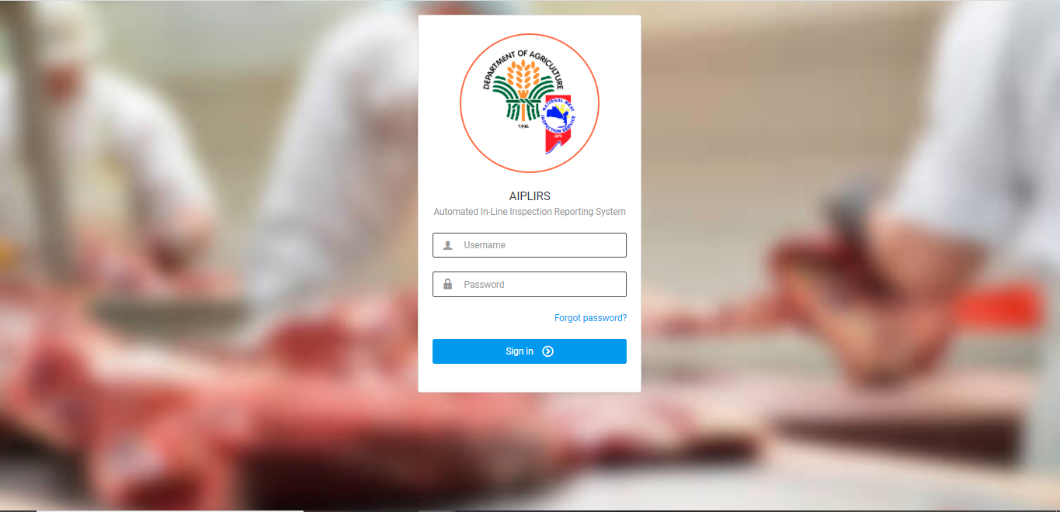

Daily Receiving Report

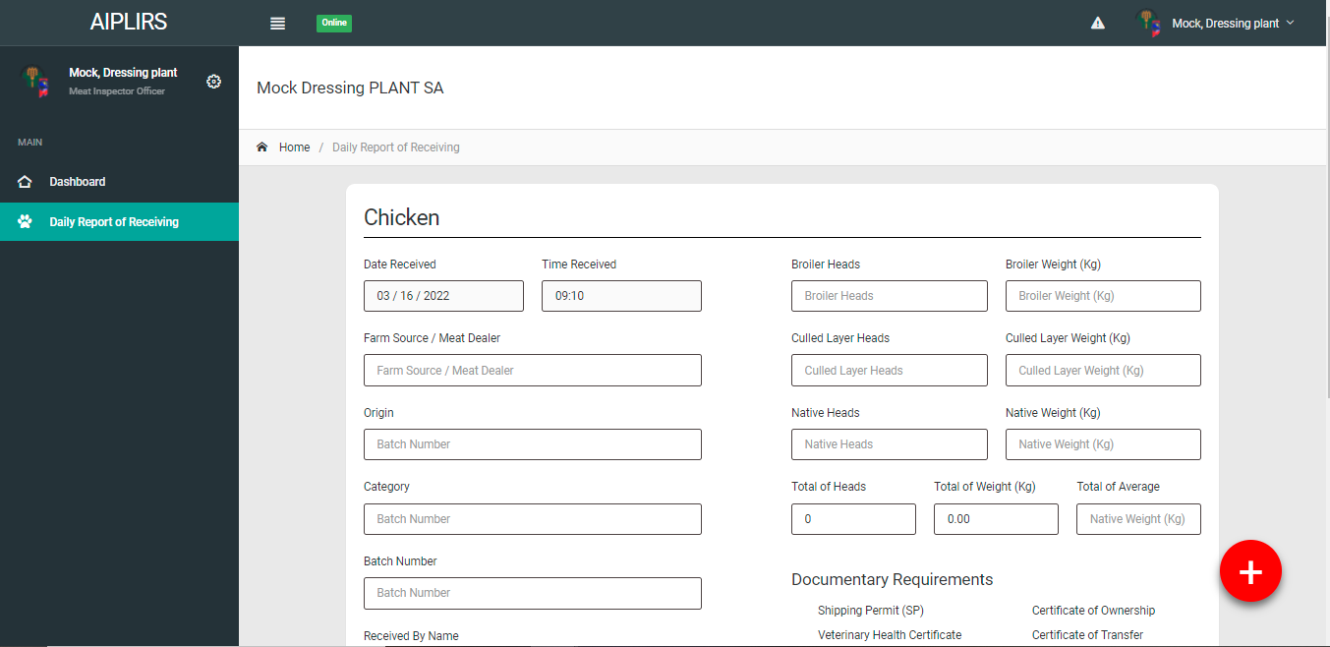

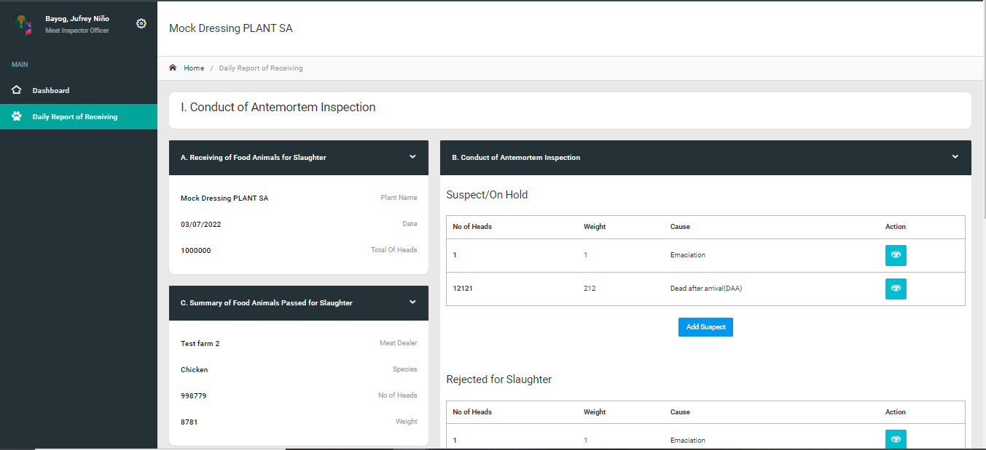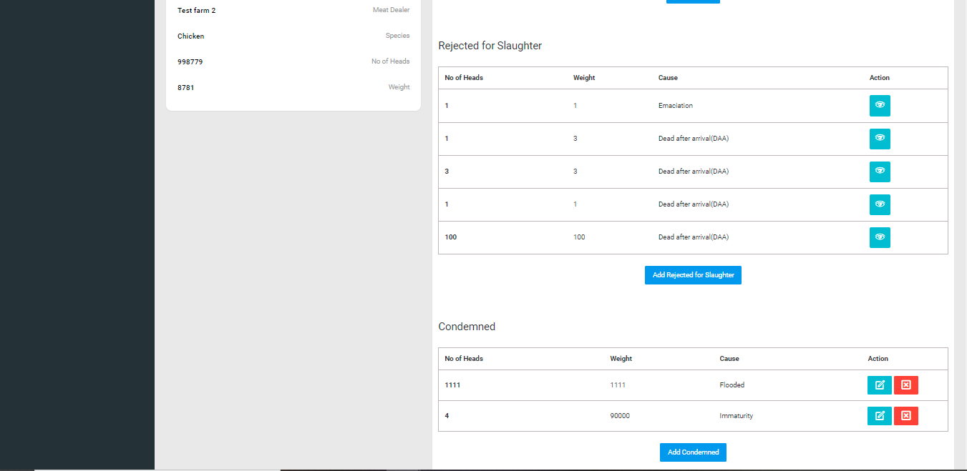

**AIPLIRS Swimlane**

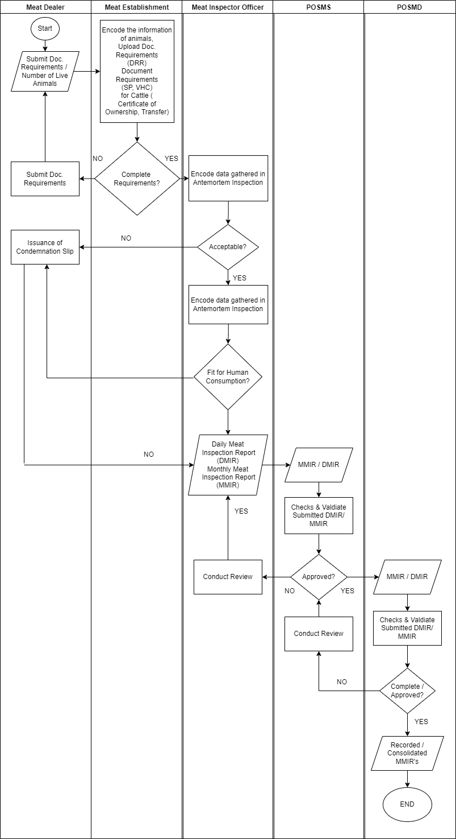

**AIPLIRS Database Structure**

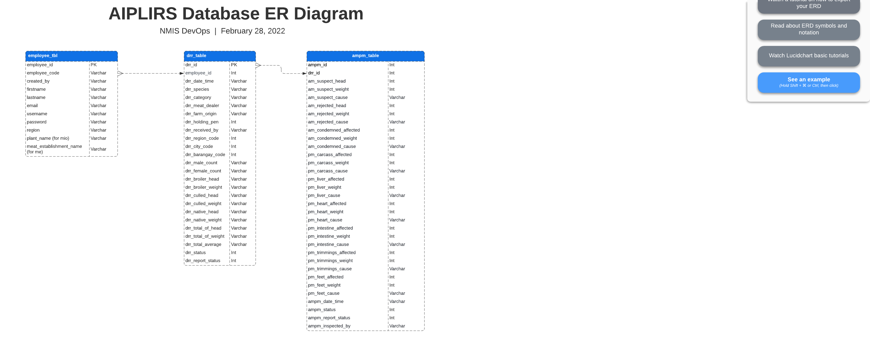

**AIPLIRS SIPOC Diagram**

|  |  |  |  |  |
| --- | --- | --- | --- | --- |
| **SUPPLIER** | **INPUT** | **PROCESS** | **OUTPUT** | **CUSTOMER** |
| Meat Establishment | Daily Receiving of Live Animals | Encoding of the number of heads, weight of the live animals received | No. of heads, weight of live animals | Meat Inspector Officer |
| Meat Inspector Officer | Antemortem Inspection data | Encoding for the Suspected / Rejected / Condemned Report | Antemortem Inspection Report / Food animals pass for Slaughter | Meat Inspector Officer |
| Meat Inspector Officer | Postmortem Inspection data | Encoding for the Carcass / Lungs / Liver / Heart / Intestines / Trimmings / Feet / Kidneys / Spleen Report | Postmortem Inspection Report | Meat Inspector Officer |
| Meat Inspector Officer | DMIR / MMIR | Submit Generate Report for DMIR / MMIR | DMIR / MMIR for approval | POSMS |
| POSMS | Validate DMIR / MMIR | Approve DMIR / MMIR Report, Inspected by Meat Inspector Officer | DMIR / MMIR Reports | POSMD |
| POSMD | Validate submitted report from the POSMS Regional Office | Approve DMIR / MMIR Report, Inspected by Meat Inspector Officer | Slaughter Reports | POSMD |